GOLDEN LEAF HANDICRAFTS

Category - Shubh-labh

Invite positive vibes into your homes with our Shubh-Labh collection. Give a new divine look to your doors and with the lord's blessings, bring in prosperity and happiness.

Adding this shub-labh on your doors not only gives your door an auspicious look, but also help to beautify it.

These handcrafted shubh labh articles also act as a perfect gift on various occasions.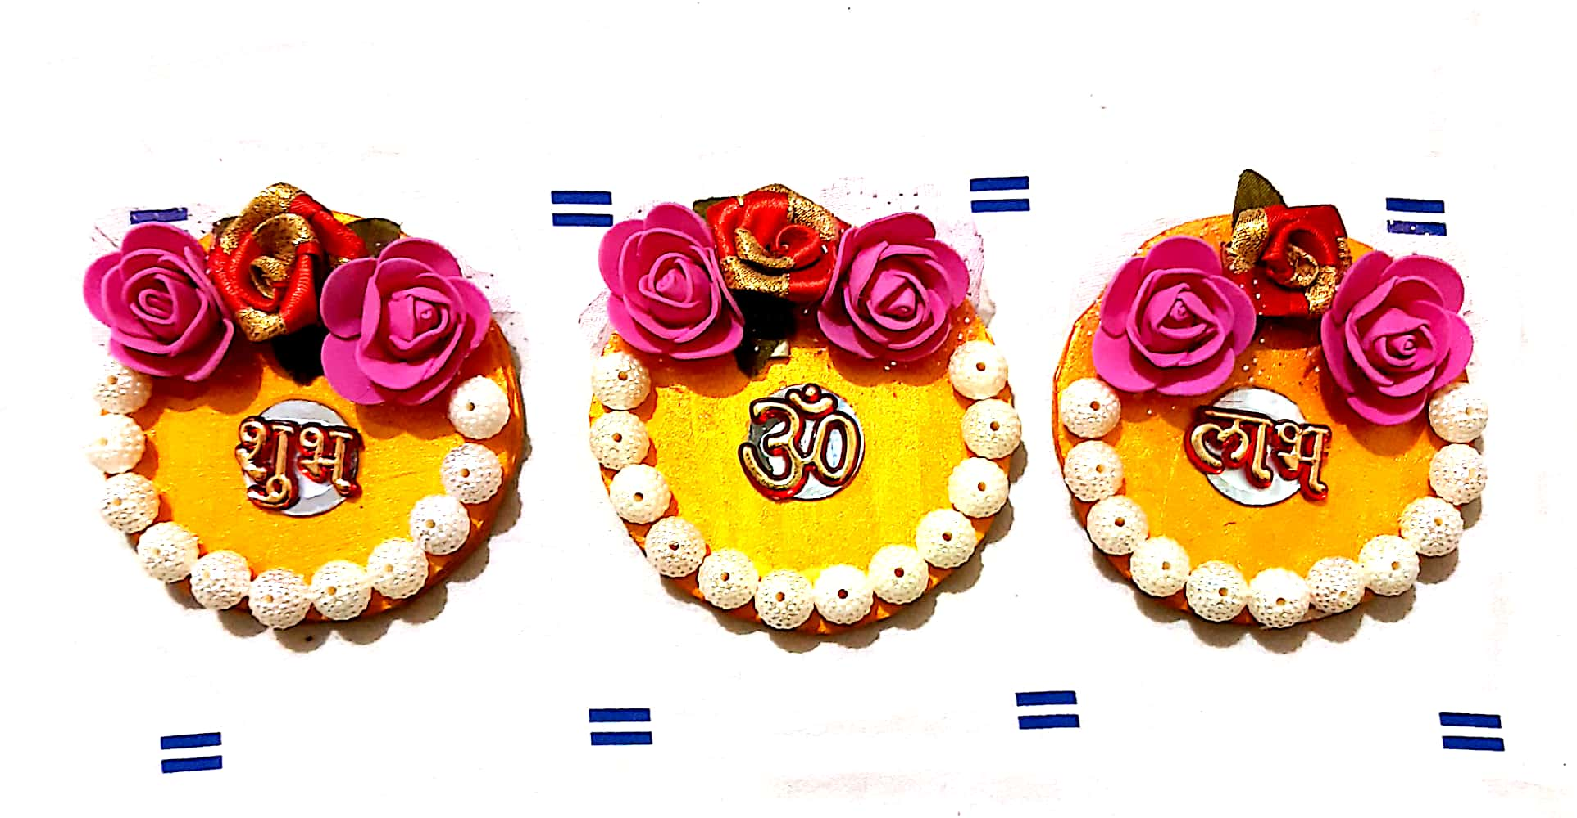

Our 3 piece golden shub-labh collection with beautifying pearls and mesmerizing roses with an OM in the center will help you invite home positive vibes and also give a new vibrant look to your doors and temples.

Purchase it just at Rs.250/-.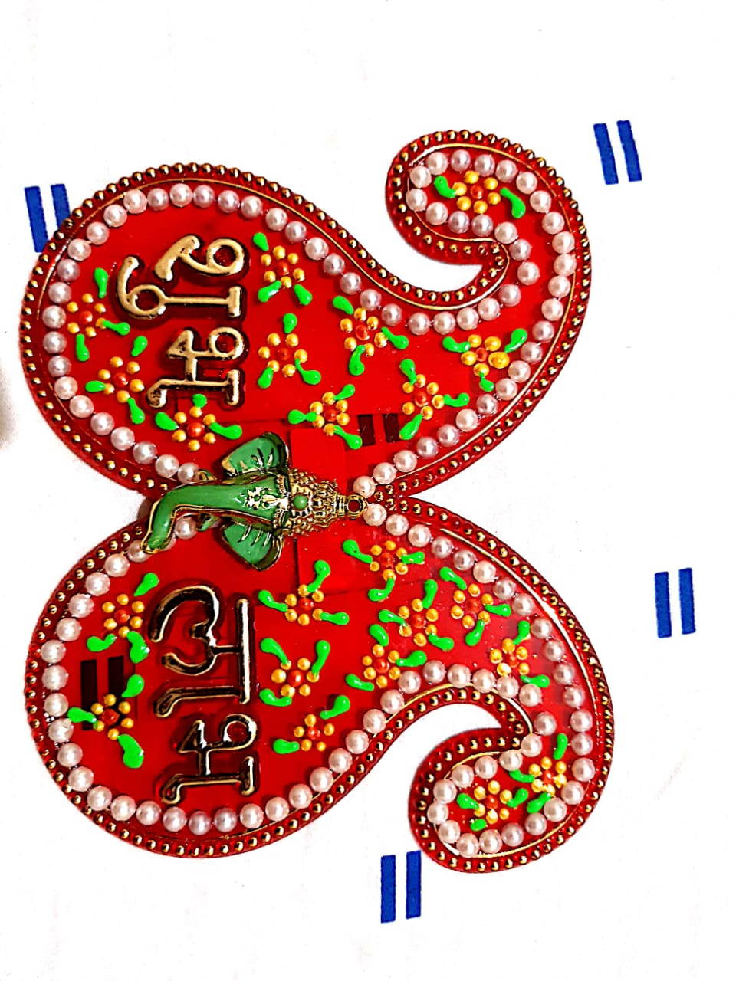

The phrase itself signifies the welcoming of auspicious vibes into your homes. With our finely designed Shubh-labh collection, we help you welcome prosperity into your homes. They're specially handcrafted by our artisians just perfect to suit your homes.

Buy them at just Rs.150/-.

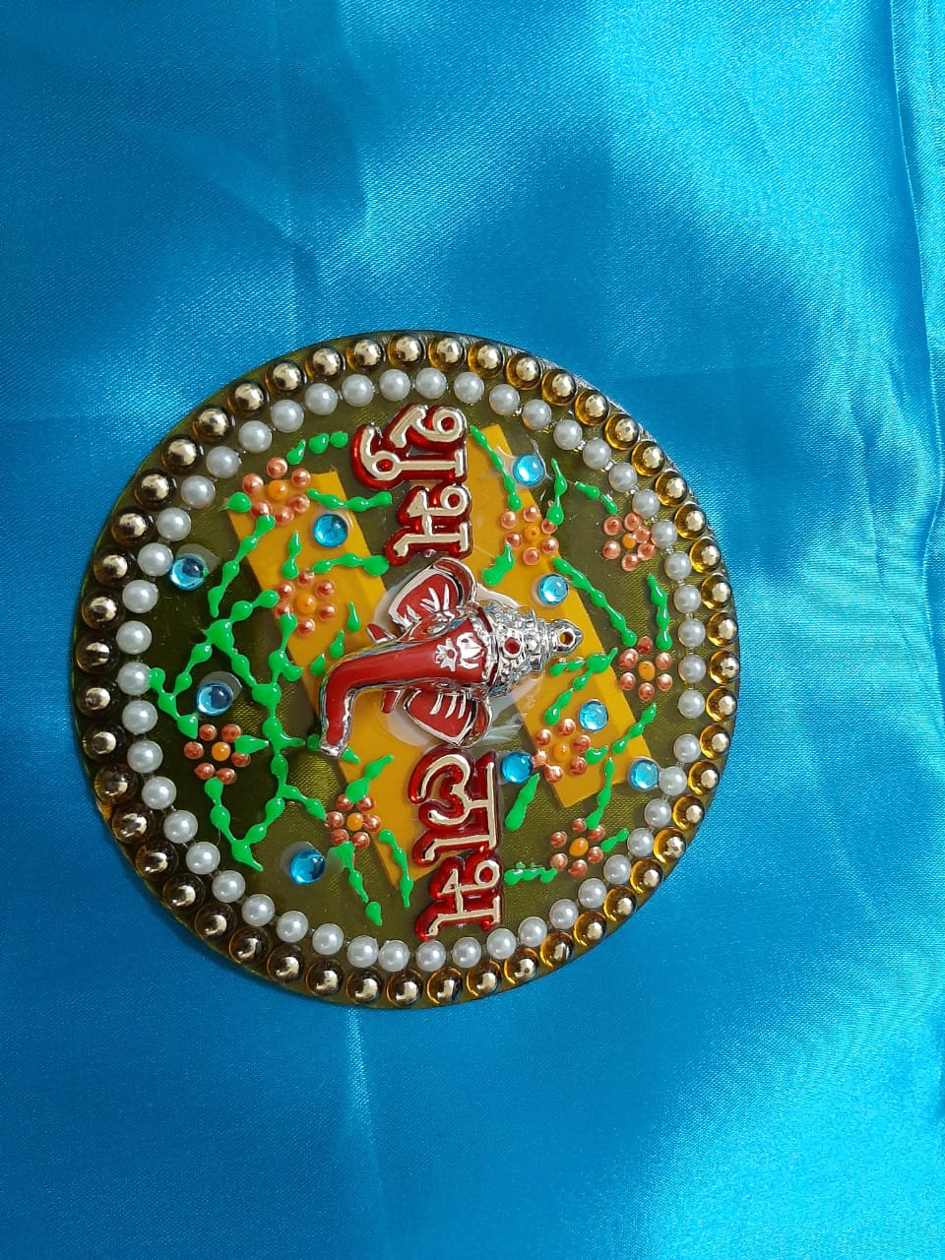

Lord Ganesha himself reflects prosperity. So our auspicious shub-labh will help you bring home prosperity and astounding success.

Purchase it now just at Rs.100/-.

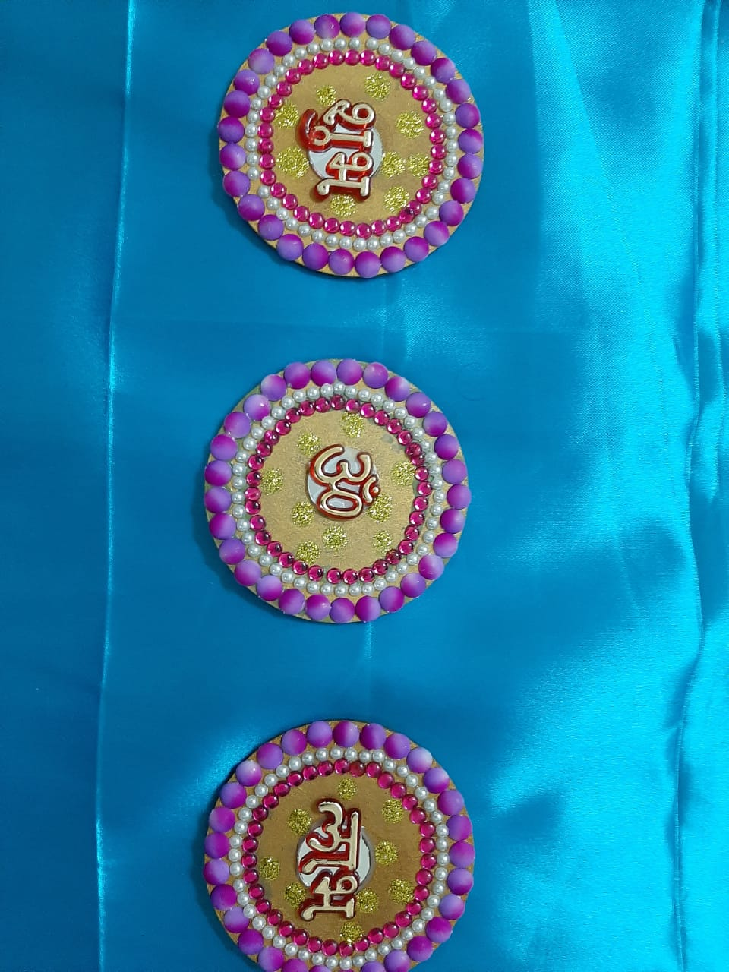

Our 3 piece beautiful Shubh-labh with beautiful pearls and beads with an OM in the center will help you invite home positive vibes.

Purchase it now at just Rs.200/-.